H.T No
Regulations:
A18

Sreenidhi Institute of Science and Technology
(An Autonomous Institution)
Code No: 7HC13 Date: 19-Dec-2022 (FN)

B.Tech II-Year I- Semester (A18) Special Supplementary Examination - December-2022
TRANSFORM TECHNIQUES AND NUMERICAL METHODS (EEE and ECE)

Time: 3 Hours Max.Marks:70

Note: a) No additional answer sheets will be provided.
b) All sub-parts of a question must be answered at one place only, otherwise it will not be valued.
c) Missing data can be assumed suitably.

ANSWER ANY 5 OUT OF 8 QUESTIONS. EACH QUESTION CARRIES 14 MARKS.

Bloom's Cognitive Levels of Learning (BCLL)
Remember | L1 | Apply | L3 | Evaluate | L5
Understand | L2 | Analyze | L4 | Create | L6

 |  |  | BCLL | CO(s) | Marks
1. | a) | Find the Laplace transforms of 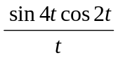. | L5 | CO1 | [7M]
 | b) | Evaluate 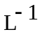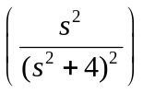. | L5 | CO1 | [7M]
2. | a) | Evaluate Z transform of cosnθ and sinnθ. | L5 | CO2 | [7M]
 | b) | Find Inverse Z transform of 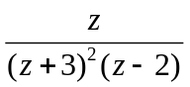 | L5 | CO2 | [7M]
3. | a) | Solve the equation x²p+y²q=z². | L4 | CO3 | [7M]
 | b) | Solve the equation zpq=p+q. | L4 | CO3 | [7M]
4. | a) | Using bisection method find the approximate root of the equation  x³-x-1=0 . | L3 | CO4 | [7M]
 | b) | Find the approximate root of the equation xe^{x}=cosx using Regula-Falsi method. | L3 | CO4 | [7M]
5. | a) | Fit a polynomial using Newton’s forward interpolation formula to the following data | L4 | CO5 | [7M]
  x | 40 | 50 | 60 | 70 | 80 | 90
  y | 184 | 206 | 228 | 254 | 278 | 310
 | b) | Find a polynomial using Lagrange’s Interpolation formula to the following data | L5 | CO5 | [7M]
  x | 0 | 2 | 3 | 6
  f(x) | 459 | 605 | 648 | 884
6. | a) | Apply Range – Kutta method of 4th order find the solution of 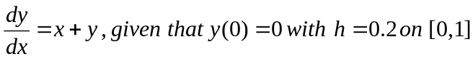 | L3 | CO6 | [10M]
 | b) | Write Runge-Kutta second and fourth order formulae. | L1 | CO6 | [4M]
7. | a) | Using Z- transforms, solve the difference equation u_{n+2}+6u_{n+1}+9u_{n}=2^{n} with u₀=u₁=0. | L3 | CO1 | [10M]
 | b) | Find the Laplace transform of e^{2t} sin 4t. | L5 | CO2 | [4M]
8. | a) | Solve y¹-y²=0 ,y(0)=1 at x=0.1and 0.2 by Euler’s method. | L3 | CO4 | [7M]
 | b) | Find the Laplace transforms of . | L3 | CO5 | [7M]
-- 00 -- 00 –

